Date Team ID
Project Name Maximum Marks
IdeationPhase
Define the Problem Statements
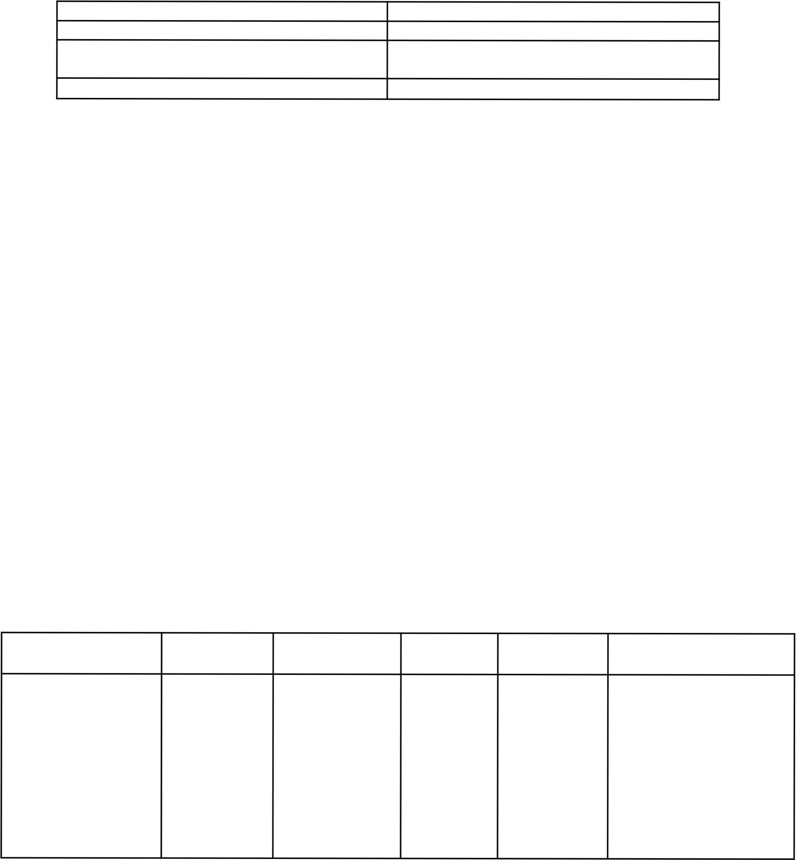
3 December 2025

SHOPEZ : E-commerce Application
2 Marks

Customer Problem Statement Template:
E-ShopEase aims to address the challenges customers face while shopping online. Many users struggle to find products easily, compare prices, track orders, and complete purchases efficiently. Sellers also face difficulties managing inventory, processing orders, and reaching customers effectively. These issues lead to poor user experience, delayed deliveries, and reduced customer satisfaction. E-ShopEase seeks to provide a seamless digital platform that simplifies product discovery and purchasing for customers while enhancing operational efficiency for sellers.

Customer Problem Statement Template

I am
I’m trying to
But
Complicated Browsing & Filtering
Most e-commerce sites show too many irrelevant products, confusing filters, and poorly organized
Because
Lack of Reliable Information
Customers don’t receive accurate details about product availability, delivery dates, or seller
Unorganized Platform Workflow
Many platforms struggle to manage product listings, stock updates, deliveries, and seller coordination efficiently
Which makes me feel

Product Discovery Difficulty

Customers find it hard to search for the right product and compare prices in one place.

Low Trust & Checkout Abandonment
The confusing experience increases frustration, reduces trust, and leads to abandoned carts.

Problem Statement (PS) I (Customer) Trying to But Because Which makes me feelt

PS-1

An online shopper.

Find the right product and compare prices easily.
Most e- commerce platforms show too many irrelevant products, and the filters/search results are confusing.
There is no simple, personalized system that helps users find suitable products based on needs, budget, or reviews.

Overwhelmed and frustrated, often leading me to abandon the search.



PS-2
A customer trying to place an order.
Buy products quickly and smoothly.
The checkout process feels long, with too many steps and unnecessary information.
There is no streamlined checkout flow or auto- filled user details to speed up the process.

Annoyed and impatient, causing cart abandonment.

